Map Name: |  | Version 0.61: 21-09-2013  Mistakes? More tiles? Give feedback: robotsquare.com




Draw your own map here! Instructions:

- To print a specific track, enter the tile numbers in the ‘Page’ field in your printer settings. For example:

2,2,2,2,3,3,3,3,11

This results in a rounded square.

- Print at 100%. Do not scale.

Each tile (200x200 mm) fits either A4 or US letter paper.

- Cut along the dashed lines.

- If you like, add symbols to the corner triangles like domino tiles. This helps rebuild your track later on. For example:

A A

B C

Tile Type # 2
© Robotsquare.com

Tile Type # 3
© Robotsquare.com

Tile Type # 4
© Robotsquare.com

Tile Type # 5
© Robotsquare.com

Tile Type # 6
© Robotsquare.com




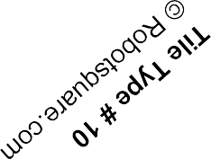

Tile Type # 11
© Robotsquare.com

Tile Type # 12
© Robotsquare.com

Tile Type # 13
© Robotsquare.com

Tile Type # 15
© Robotsquare.com

Tile Type # 16
© Robotsquare.com

Pass Here

Tile Type # 17
© Robotsquare.com

Tile Type # 33
© Robotsquare.com

This page intentionally left blank

